Touchstone Lab: Troubleshooting a Wireless Connection
Name: Francisca Falaise
Date: 3/24/2026

Section 1: Overview
In this lab, I used Cisco Packet Tracer to troubleshoot a wireless network connectivity issue. The goal was to identify and resolve problems preventing a device from connecting to a wireless network.

Section 2: Troubleshooting Process
I followed a structured troubleshooting approach to diagnose and fix the issue. First, I verified the wireless settings and confirmed the correct SSID was selected. Next, I checked the IP configuration to ensure the device received a valid IP address. I used command-line tools such as ping and ipconfig to test connectivity and identify potential network issues. I also reviewed the wireless router configuration within the virtual environment. After identifying the root cause, I applied the necessary corrections and restored network connectivity.

Section 3: Outcome
The wireless connection issue was successfully resolved, and the device was able to connect to the network. The Packet Tracer activity reached a 100% completion rate, confirming that all troubleshooting steps were completed correctly.

Section 4: Screenshot
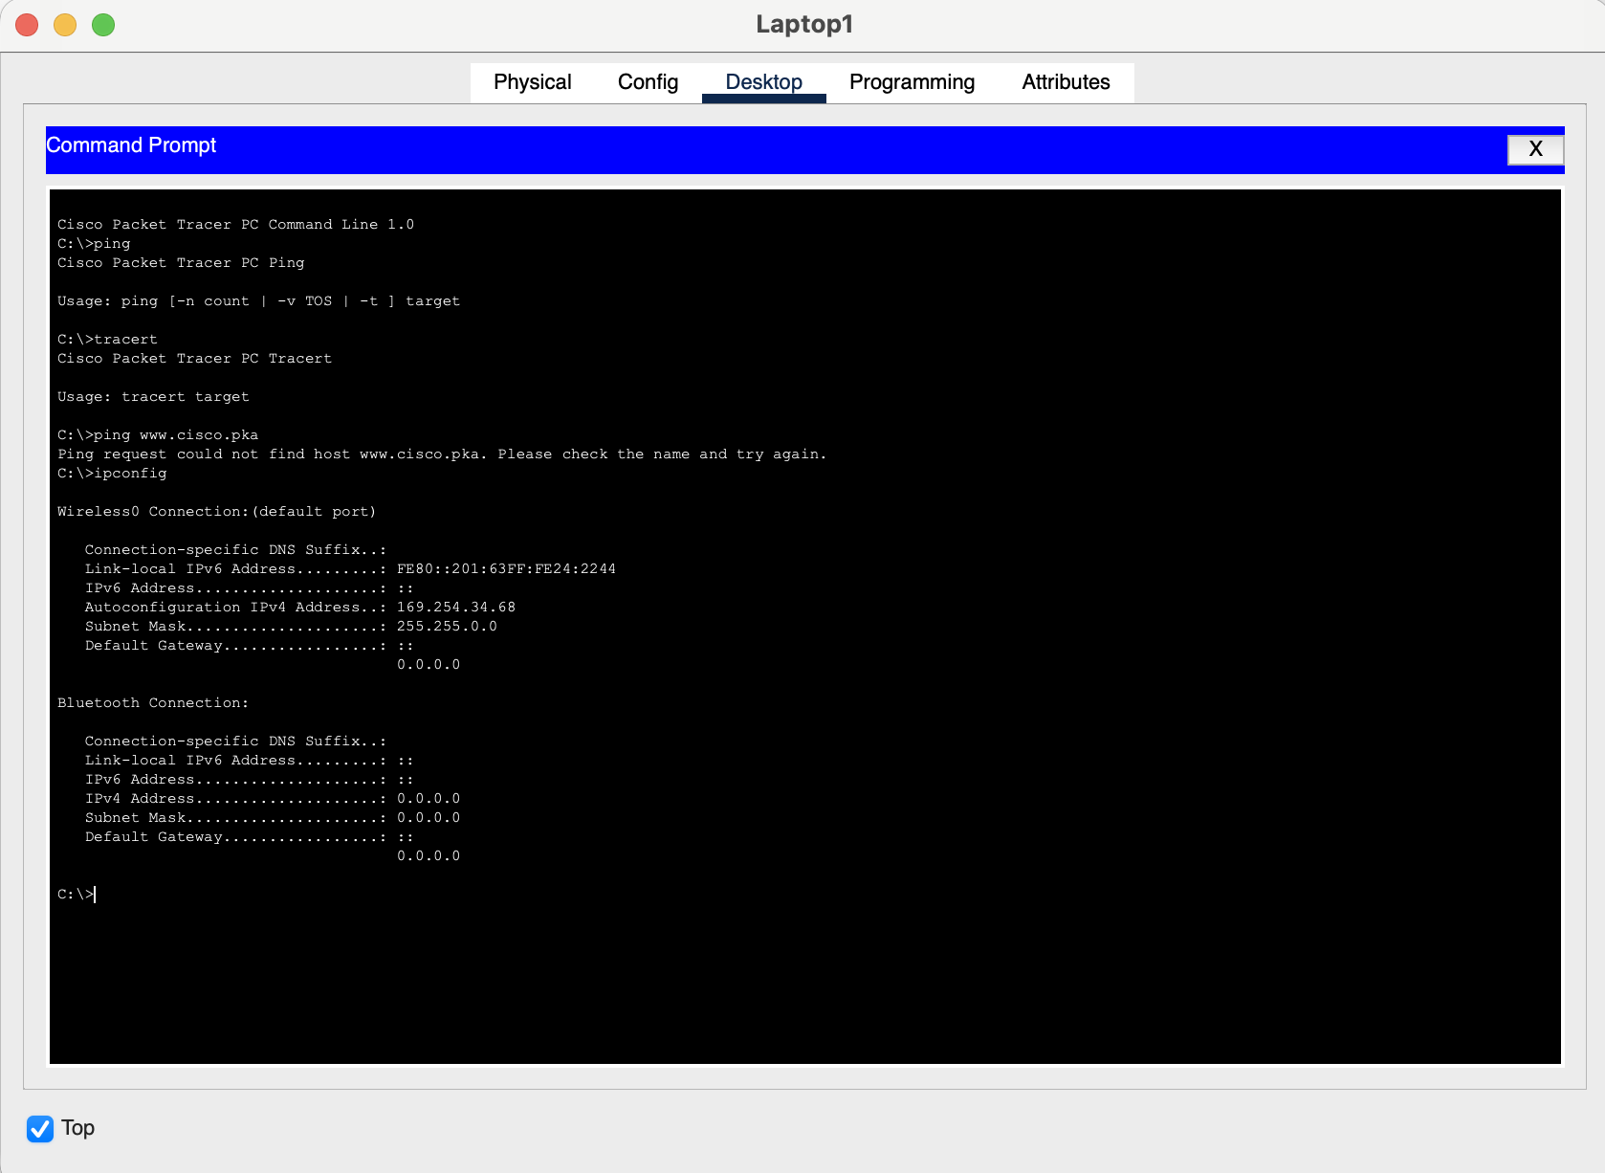
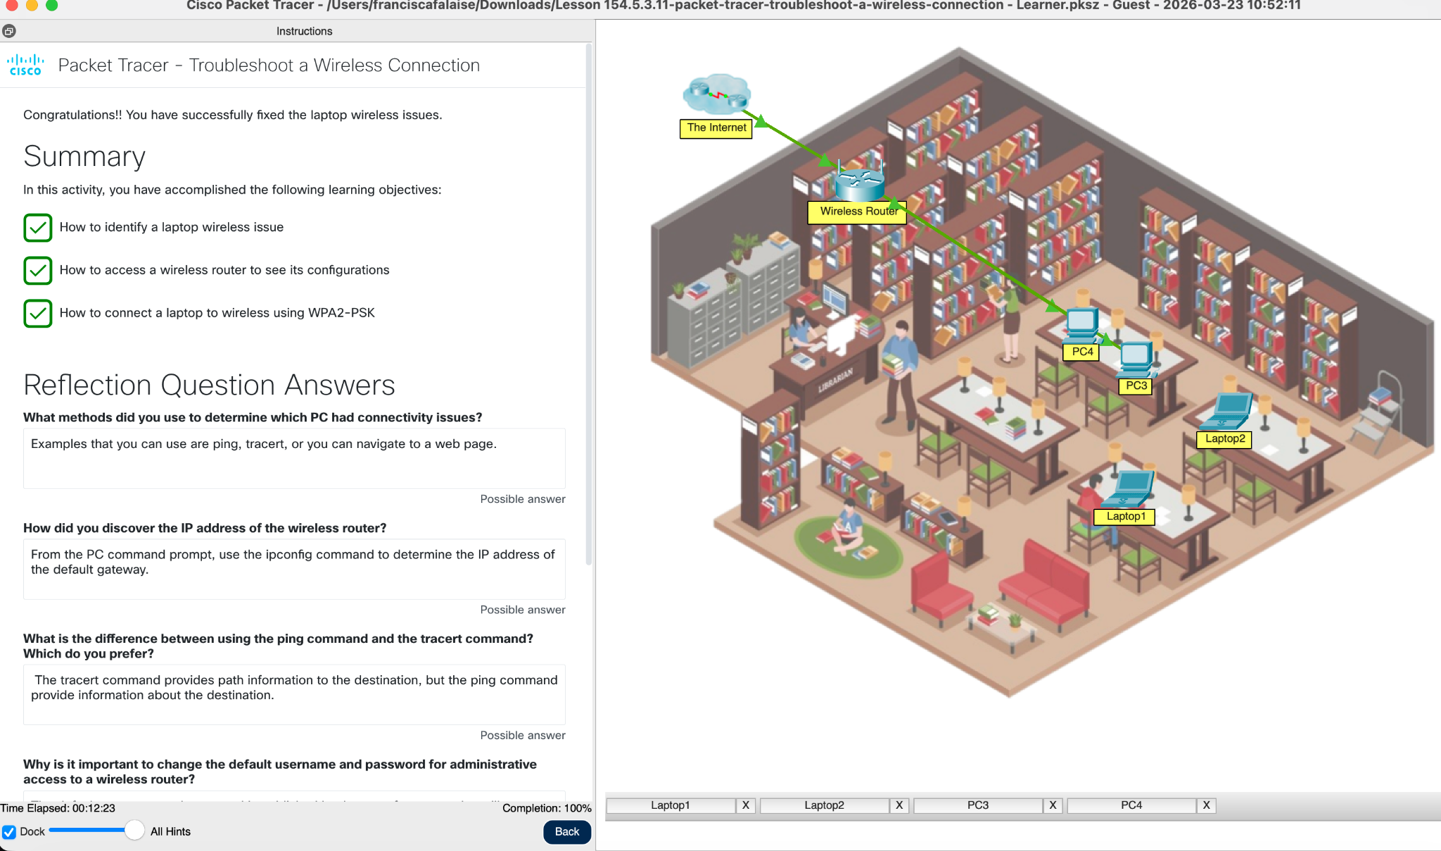

Section 5: Skills Demonstrated
- Network troubleshooting
- IP configuration (ipconfig)
- Connectivity testing (ping)
- Wireless networking concepts
- Problem-solving and diagnostic methodology

